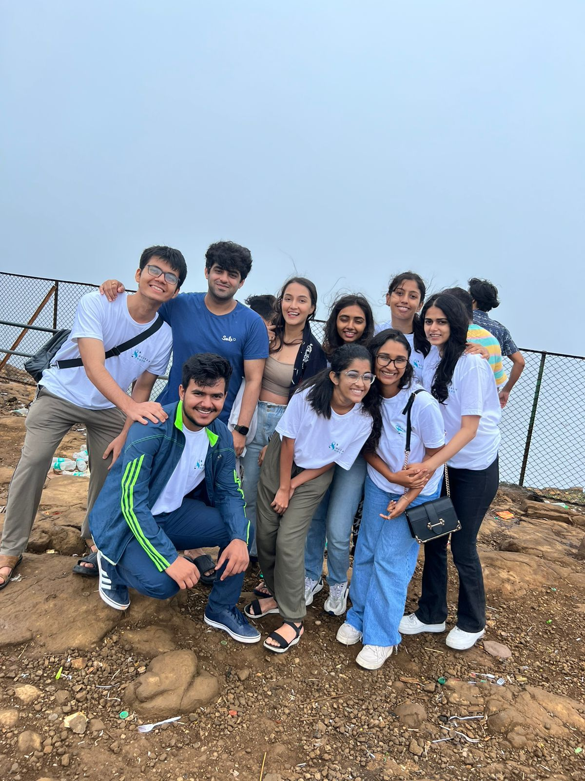
I was a lead strategist in the mental health sector for over a year.

As is the case for most early-stage startups- positions of responsibility mean you need to get your hands dirty in almost every operational unit.

Ideating and strategising for products, managing creative and technical teams, understanding media dynamics, building community, taking interviews, understanding business models and most importantly- Gaining clarity on things we *did not* want to do.

Success, failure, and iterations.

What did we end up achieving in about a year?

- Building a massive online presence. Socially Souledis the most followed Indian non-individual Instagram psychology page, with a 70k+ strong community.

- Developing and launching 4 distinct offerings. A therapy platform, a learning platform, Mental health merch, and career guidance programmes.

We were loved by the people, we helped psych students on a daily basis.

The team was able to create content, launch products, and teach people, while consistently aligning with a larger vision - we were stretched thin, but the impact was worth it.

Every Psych student in India had a first contact who knew about us, and people used to be surprised knowing I, a final year student was spearheading the backend work.

I thought creating a comprehensive ecosystem that could cater to the complete cycle of what a Psych student needs, along with creating positive identity tropes for people in therapy would solve the problem.

It is about therapists, clients, awareness, campaigns, collaborations and, amazing products that will "solve everything",

right?

Wrong.

People say "Oh there is taboo and stigma and that is why mental health businesses fail".

10-year-olds know that too.

What does taboo really mean? what factors maintain the stigma around mental health? what kind of language do people use when approaching a mental health practitioner?

Friends who interned in clinical setups used to tell me someone with anxiety does not come to a psychologist first - They see a cardiologist.

After spending 5 Lakhs doing all sorts of tests, not believing what the first Doctor told them and running around 7 hospitals to find the "real cause", do they finally see an MHP.

It is not just that "therapy is expensive", therefore providing a "first session free" would do the trick-

- The cost of reaching a mental health practitioner itself is very high. -

Read that again.

Mental health organisations need to stop functioning like other businesses.

You cannot bring "cut-throat" competitions amongst yourself where you have to "beat the competition", you're not selling biscuits for heaven's sake.

You operate at a nexus of social, economic, cultural, linguistic, informational, geographic and political realities- add policy to that list too.

I was not equipped to understand it all, So I chose to relearn how systems and people interact.

I'm still true to my cause, But I realised I needed a different path.

We need to wake up.

